Transmission of socioeconomic status over generations: mediated by the family trajectory?
Joanne Sophie Muller, Nicole Hiekel, & Aart C. Liefbroer
Key words: intergenerational social mobility, family trajectory, earnings

Extended abstract

Introduction
Most studies on intergenerational socioeconomic status (SES) mobility focus on men and on early adult outcomes. However, processes of SES mobility may differ between men and women, and depend on life course stage. In particular, gender differences in family trajectories and the different roles of men and women in these family trajectories may play a role. Given this background, the present study will address three questions. First, how different is the association between parental SES and later life personal earnings between men and women? Second, to what extent do family trajectories mediate the transmission of parental SES, and does the strength of mediation differ between men and women? Third, to what extent do these processes differ across countries?
We reason that children imply a ‘care burden’ to parents who have to negotiate the time they invest in employment and family care. Parents have to choose: investing more in their labour market participation will increase their earnings at later age, but decreases time available for family care. The way people handle the care burden differs by gender, but may also differ by parental SES for at least three reasons. First, higher parental SES may be associated with more egalitarian gender role attitudes, hence women will be more motivated to pursue a career and men will be more motivated to do care for dependent children. Second, men and women whose parents have a high SES may have higher earnings themselves which increase their ability to outsource caring tasks. This may be particularly beneficial for women’s labour market participation. At the same time, low parental SES has been found to be associated with disadvantageous events in the family trajectory, such as early parenthood, divorce and single parenthood. Moreover, the adverse consequences of these events may be more severe for women than for men. Therefore, a major role in intergenerational transmission of SES might be the intergenerational transmission of opportunity to focus on paid labour.
Most studies explain country differences in levels of intergenerational mobility by national educational systems. We above have argued how parental SES shapes individual’s opportunities to accumulate higher earnings later in life. However, the cultural value and policy climate increases or decreases mothers’ (and fathers’) opportunities to remain economically active during childrearing. This research therefore has possible implications for the research on intergenerational mobility and policy making more general.

Data
Data stem from the first wave of the Generations and Gender Programme (GGP), the British Household Panel Survey wave 15 and SHARE wave 3 (SHARELIFE). These surveys contain retrospective fertility and partnership histories as well as information about parental educational level, parental employment and the respondent’s current employment and earnings. The data were collected around 2008. Given the focus on later life earnings we select men and women aged 50 to 59 at the time of interview. Our total analytical sample consists of 36.728 individuals from 23 European countries which are Austria, Belgium, Bulgaria, Czech Republic, Denmark, Estonia, France, Georgia, East-Germany, West-Germany, Greece, Hungary, Ireland, Italy, Lithuania, Netherlands, Norway, Poland, Romania, Spain, Sweden, Switzerland and the United Kingdom.

Variables
The outcome of interest is personal net earnings, by which we mean earnings from a job or earnings from self-employment. The main independent variable is parental SES which is operationalised in two different ways. First by the parental educational level which is measured by the sum of the highest level of education (ISCED) of father and mother. Second, by a dummy variable indicating mother’s employment when the respondent was 15 years old.
The mediating variable of interest is the respondent’s family trajectory. Family trajectory is measured as a sequence of yearly intervals from age 18 to 50. This implies that we created a sequence of 32 chronological states for every person in the dataset. We specified eight possible states based on a combination of the age of the youngest child and partnership status: (1) No child, no partner; (2) No child with partner; (3) Youngest child 0-3, no partner; (4) Youngest child 0-3 with partner; (5) youngest child 4-11, no partner; (6) youngest child 4-11 with partner; (7) youngest child 12+, no partner; (8) youngest child 12+ with partner.
In order to explain country variation, we used two indicators for gender inequality. First, the ratio of female to male labour force participation in 1980. We derived this measure from the GGP Contextual Database. Second, using data from the 1990 European Value survey data, we created the “familialism values” index. This index covers the statements regarding care for children and gender role norms.

Analytical approach
Our analytical approach consisted of two parts. First we created a typology of family trajectories using sequence cluster analysis. This means that sequences with the smallest distance to each other were clustered together. To determine the most appropriate number of clusters, we considered several cluster cut-off criteria. The strength of sequence analysis is that is provides a holistic view of trajectories. This allows us to determine trajectory patterns by taking into account ordering and timing of events and duration of spells. Second, we used the family trajectory typology in regression models to assess whether it mediated the association between parental SES and later life personal earnings.
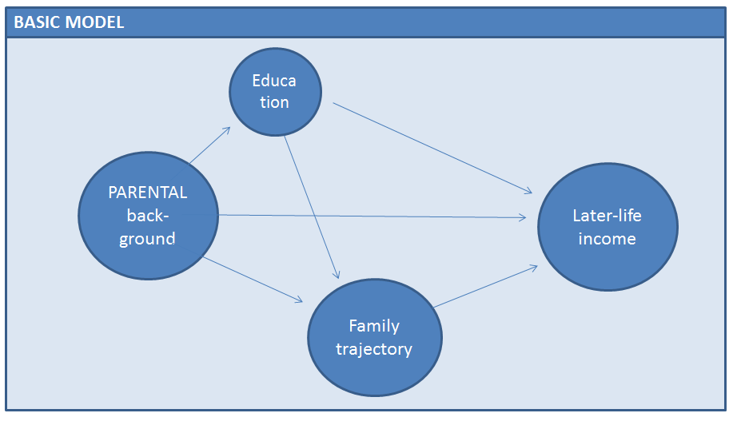

The research leading to these results has received funding from the European Research Council under the European Union's Seventh Framework Programme (FP/2007-2013) / ERC Grant Agreement n. 324178 (Project: Contexts of Opportunity. PI: Aart C. Liefbroer).

